# DAD 220 Project Two Template

## Overview

Review the scenario for this activity in the guidelines and rubric. Then complete the steps below as you work through the directions for this activity. Replace the bracketed text with your screenshots and responses to the prompts. Size each screenshot and its explanation to fit approximately one-quarter of the page with the description written below the screenshot. Review the Template Screenshot Example linked in the guidelines and rubric for this assignment to see an example of how screenshots for your assignment should look.

## RMA Report

Write a report to respond to the manager’s requests. In the report, you should complete the following actions:

* Summarize the data you’ve been working with.
* Identify key information that will help the company streamline operations.

Your report should explain your findings in a way nontechnical stakeholders can understand and use.

Use the steps below to capture the required data and produce the analysis report.

1. Begin by writing SQL commands to **capture** specific **usable data** for your analysis. You already preloaded the data you need into Codio.
2. Specifically, the product manager wants you to complete the following analysis:
   1. **Analyze** the number of **returns by state** and describe findings to include in your report.

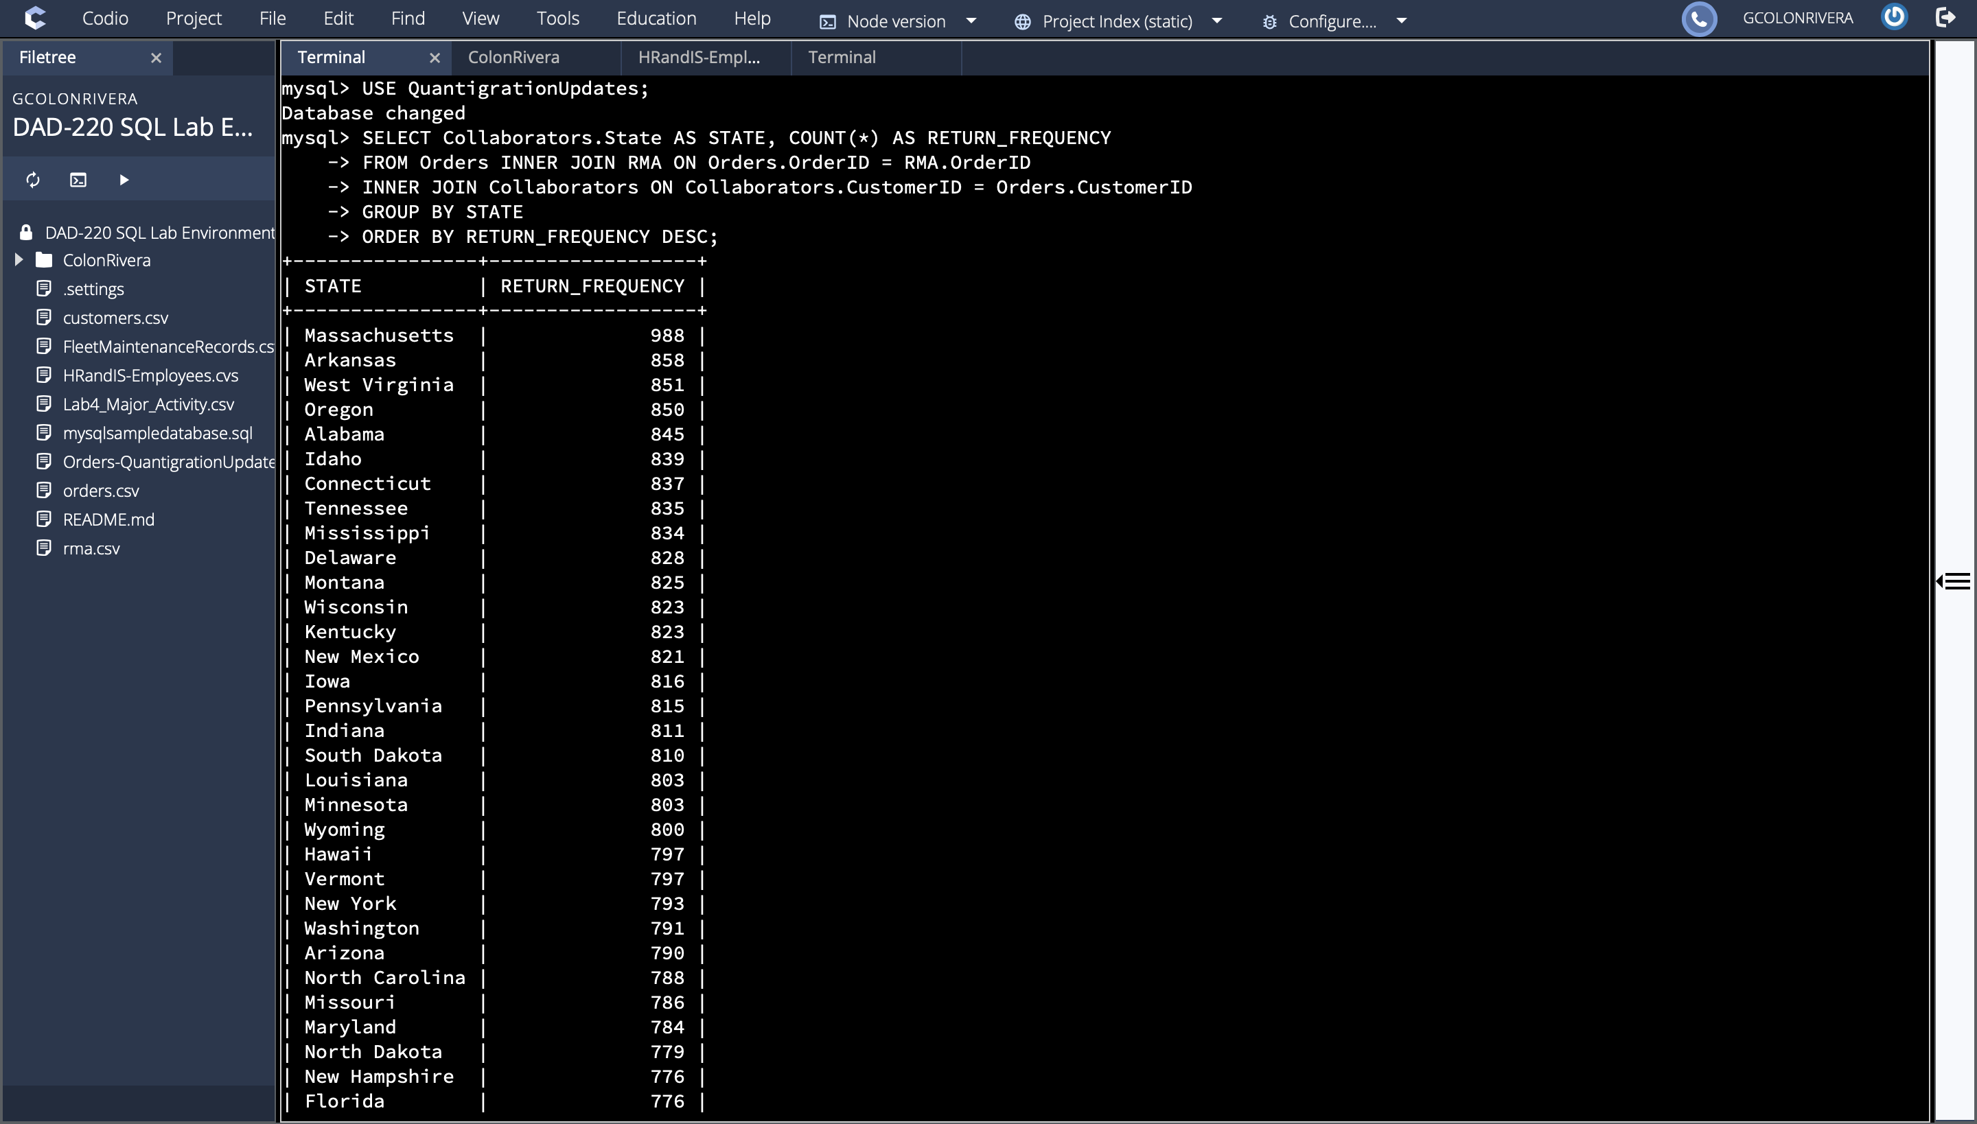

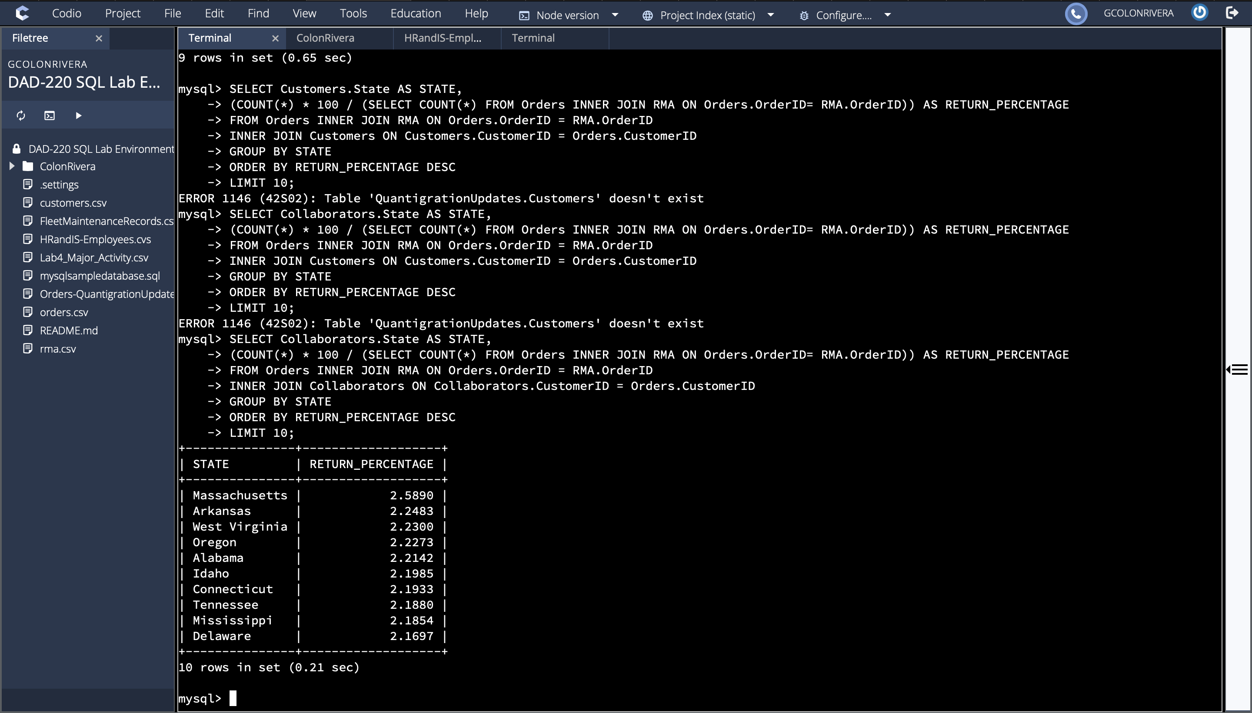

The Screen captures show the the states with the most returns and the return percentages with Massachusetts, Arkansas, and West Virginia be the leading states with returns in order they had 988, 858, and 851. The leading products returned in were the BAS-88-1 C(Massachusetts), ENT-48-48F(Arkansas), and ENT-48-48F(West Virginia).

* 1. **Analyze** the percentage of **returns by product type** and describe findings to include in your report.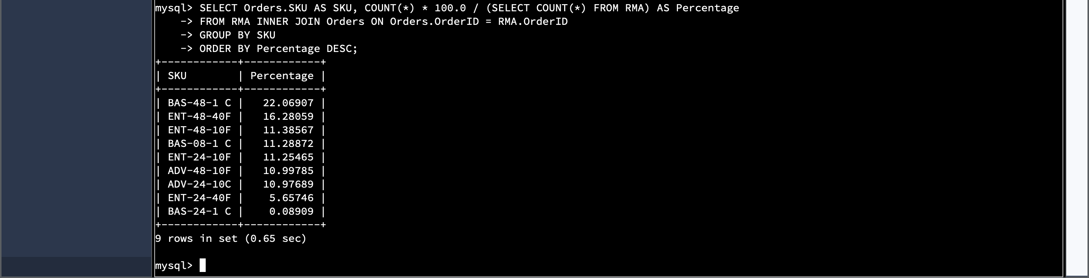

The percentage of the returns of product BAS-48-1 C is 22% follow by ENT-48-40F which is at 16% , 6% less than the leading returned product, The third item ENT-48-10F is at 11% half of the first product.

1. Write a report to clearly **summarize** your RMA **data analysis** for stakeholders. When you summarize the results, consider the following questions:
   1. How does the data provide the product manager with usable information?

All the information seen and captured is very usable by the product manager. It lets the product manager know where the products where being sold and how they are doing and what is being returned and based on the returns it can determine why they are being returned.

* 1. What are the potential flaws in the data that has been presented?

This information does not fully show the exact reasons as to why the products were returned and if the products could have come from the same customer who ordered them or came from the same store.

* 1. Are there any limitations on your conclusions or any other ways of looking at your findings that you haven’t considered? Clearly communicate your findings to stakeholders.

We could go so in depth as searching cities within a state, but going by state is a better way because there would be way too many cities to search through and many more variables to notice by cities.

As seen, 7 out of the 9 products in this list are above a return frequency of 10% which is exceedingly high for those 7 products, but also the BAS-48-1 C specifically is at 22% that is extremely high and may need more immediate attention than the other products. I would investigate the top 3 returned products to find exactly why they are being returned and decide if we need to replace them with another product or simply change the QA process for the products. Figuring out the way the products are manufactured could be enough to lower the large number of returns.